**SPH3U: 1.5 Five Key Equations for Motion with Uniform Acceleration**

1. **A displacement equation**

|  |  |
| --- | --- |
| Area under a V-T graph: |  |

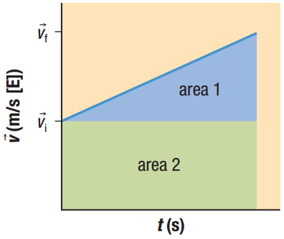Find the area under the graph to the right. This is Equation 1!

Solve the average acceleration equation for *vf*. This is Equation 2!

Substitute *vf* into the first equation. This is Equation 3!

1. **The five key equations of accelerated motion**

|  |  |  |  |
| --- | --- | --- | --- |
|  | **Equation** | **Variables in the equation** | **Variables not in the equation** |
| **Equation 1** | $$∆\overset{⃑}{d}=\left(\frac{\overset{⃑}{v_{f}}+\overset{⃑}{v_{i}}}{2}\right)∆t$$ |  |  |
| **Equation 2** | $$\overset{⃑}{v_{f}}=\overset{⃑}{v_{i}}+\overset{⃑}{a}∆t$$ |  |  |
| **Equation 3** | $$∆\overset{⃑}{d}=\overset{⃑}{v_{i}}∆t+\frac{1}{2}\overset{⃑}{a}{∆t}^{2}$$ |  |  |
| **Equation 4** | $$∆\overset{⃑}{d}=\overset{⃑}{v_{f}}∆t-\frac{1}{2}\overset{⃑}{a}{∆t}^{2}$$ |  |  |
| **Equation 5** | $${\overset{⃑}{v_{f}}}^{2}={\overset{⃑}{v_{i}}}^{2}+2\overset{⃑}{a}∆d$$ |  |  |

A sports car approaches a highway on-ramp at a velocity of 20.0 m/s [E]. If the car accelerates at a rate of 3.2 m/s2 [E] for 5.0 s, what is the displacement of the car?

|  |
| --- |
| $$\overset{⃑}{a}$$ |
| $$\overset{⃑}{v_{f}}$$ |
| $$\overset{⃑}{v_{i}}$$ |
| $$∆\overset{⃑}{d}$$ |
| $$∆t$$ |

A sailboat accelerates uniformly from 6.0 m/s [N] to 8.0 m/s [N] at a rate of 0.50 m/s2 [N]. What distance does the boat travel?

|  |
| --- |
| $$\overset{⃑}{a}$$ |
| $$\overset{⃑}{v_{f}}$$ |
| $$\overset{⃑}{v_{i}}$$ |
| $$∆\overset{⃑}{d}$$ |
| $$∆t$$ |

A dart is thrown at a target that is supported by a wooden backstop. It strikes the backstop with an initial velocity of 350 m/s [E]. The dart comes to rest in 0.0050 s.

1. What is the acceleration of the dart?

|  |
| --- |
| $$\overset{⃑}{a}$$ |
| $$\overset{⃑}{v_{f}}$$ |
| $$\overset{⃑}{v_{i}}$$ |
| $$∆\overset{⃑}{d}$$ |
| $$∆t$$ |

1. How far does the dart penetrate into the backstop?

|  |
| --- |
| $$\overset{⃑}{a}$$ |
| $$\overset{⃑}{v_{f}}$$ |
| $$\overset{⃑}{v_{i}}$$ |
| $$∆\overset{⃑}{d}$$ |
| $$∆t$$ |

**Homework:** page 39: #1-4